My KhataBook
A Budget and Expense Management System

Project Report

SUBMITTED IN PARTIAL FULFILLMENT OF THE REQUIREMENT FOR THE AWARD OF THE DEGREE OF

Bachelor Of Technology
Computer Science Engineering

Submitted By

Raj Vardhan Singh
(2103490100026)

December 2024


Dr. APJ Abdul Kalam Technical University, Uttar Pradesh
Lucknow, INDIA

CONTENT OF REPORT :

- Introduction ………………….
- Objective ………………….
- S/W, H/W Requirements .…….
- Flowcharts ……………………
- Literature Review …………….
- Technologies Required ……….
- Feasibility Study …………..….
  - Economic Feasibility………….
  - Technical Feasibility…………..
  - Operational Feasibility………...
- Output Analysis ……………….
- Conclusion …………………….
- Test Analysis ………………….
- Future Scope ………………….
- References …………………….
- APPENDIX
a. Code of the solution………...

INTRODUCTION:

In India, It is a tradition or an initial habit of tracking your monthly expenses or day-to-day expenses. Earlier it was done by writing your daily expenditure in a copy or dairy just to track it. But with the advancement of technology and science ( Particularly computer science) it is needed to have a system or tool Expense Tracker (PET) is a daily expense management system which is specially designed for non- salaried and salaried personnel for keeping track of their daily expenditure in an easy and effective way through a computerized system which tends to eliminate manual paperwork. It will also manage records in a systematic way and users can access the stored data conveniently. We have tried to design the project in such a way that users may not have any difficulty in using this application without much effort. This software can be really used by end users who have Android running devices with them. The language that we use to develop this system is Java and SQLite for databases. The Expense Tracker project is a comprehensive financial management tool designed to empower individuals and businesses to gain better control over their expenses. In an era where financial responsibility is paramount, this project serves as a valuable resource for users to monitor, analyze, and optimize their spending habits. The primary objective of the Expense Tracker is to provide a user-friendly interface that allows individuals to easily input and categorize their expenditures, whether they be fixed monthly bills, variable expenses, or one-time purchases. The project leverages advanced technologies to automate the process of recording transactions and generating insightful reports, offering users a real-time overview of their financial landscape. Additionally, the Expense Tracker incorporates robust security features to ensure the confidentiality and integrity of users' financial data. With its intuitive design, customizable categories, and interactive visualization tools, this project aims to foster financial literacy, promote responsible spending, and ultimately contribute to a more informed and financially secure community. The Expense Tracker project is a sophisticated financial management system meticulously crafted to address the growing need for efficient expense monitoring and financial planning. In today's dynamic economic landscape, individuals and businesses alike face the challenge of keeping tabs on their expenditures, and this project emerges as a solution to streamline that process. At its core, the Expense Tracker is a digital platform that enables users to record, categorize, and analyze their expenses in a seamless and intuitive manner. The user interface is designed for accessibility, ensuring that individuals with varying levels of financial literacy can navigate and utilize the platform effectively.
One of the standout features of the project lies in its ability to automate the recording of transactions. Through integration with banking systems or manual input, the platform captures and organizes financial data, reducing the burden on users to manually log every expense. This automation not only saves time but also minimizes the likelihood of errors in financial records. The Expense Tracker goes beyond mere expense recording; it facilitates a deeper understanding of spending patterns by allowing users to categorize expenses into fixed, variable, and discretionary categories. Customizable tags and labels further enhance the granularity of data, providing users with a nuanced view of their financial habits.
Real-time reporting is a cornerstone of the project, offering users instant access to visualizations and summaries of their financial activities. Graphs, charts, and reports break down expenditures over specified periods, enabling users to identify trends, pinpoint areas of overspending, and make informed financial decisions. The platform also incorporates predictive analytics, offering insights into potential future expenses based on historical data.
Security is a top priority in the design of the Expense Tracker. Stringent measures, such as encryption protocols and multi-factor authentication, safeguard the sensitive financial information stored within the platform. Privacy and data integrity are paramount, ensuring that users can trust the platform to handle their financial data securely.
In summary, the Expense Tracker project stands at the intersection of user-friendly design, automation, and data analysis, with a mission to empower individuals and businesses to take control of their finances. By providing a comprehensive and secure environment for expense management, the project seeks to contribute to financial literacy, encourage responsible spending, and ultimately foster a more economically empowered community.

OBJECTIVE:
The Expense Tracker Project has been initiated with a set of clear and ambitious objectives, recognizing the increasing need for effective financial management tools in today's complex economic landscape. The project aims to provide a comprehensive solution that goes beyond mere expense recording, fostering financial literacy, and empowering individuals and businesses to make informed and responsible financial decisions.

1. Streamline Expense Recording:
The primary objective of the Expense Tracker Project is to simplify and streamline the process of recording expenses. By developing an intuitive user interface and leveraging automation technologies, the project aims to reduce the time and effort required for users to input their financial transactions accurately. This objective aligns with the overarching goal of making financial management accessible to users of varying levels of financial literacy.

2. Automate Data Entry:
Automation is a key focus of the project, seeking to automate the data entry process as much as possible. By integrating with banking systems and supporting manual input, the platform ensures that users can effortlessly capture and organize their financial data. This not only saves time but also enhances data accuracy, minimizing errors that may arise from manual input.

3. Categorize and Classify Expenses:
The Expense Tracker Project aims to provide users with a nuanced understanding of their spending habits by allowing them to categorize expenses into fixed, variable, and discretionary categories. Customizable tags and labels further enhance the granularity of data, enabling users to gain insights into specific spending patterns and areas of financial focus.

4. Real-time Reporting and Analysis:
A key objective is to offer users real-time access to comprehensive reports and analysis of their financial activities. Graphs, charts, and reports break down expenditures over specified periods, facilitating the identification of trends and areas of overspending. The platform incorporates predictive analytics to provide users with insights into potential future expenses based on historical data.

5. Enhance Financial Literacy:
Beyond the functional aspects, the Expense Tracker Project aims to contribute to financial literacy. The project includes educational components that help users understand financial concepts, interpret reports, and make informed decisions. By providing resources and insights, the project seeks to empower users to take control of their financial well-being.

6. Ensure Security and Privacy:
Security is a paramount objective of the Expense Tracker Project. The platform incorporates stringent security measures, including encryption protocols and multi-factor authentication, to safeguard users' sensitive financial information. Ensuring the privacy and data integrity of users is a foundational goal, establishing trust in the platform's handling of financial data.

In conclusion, the Expense Tracker Project sets out to achieve a multifaceted set of objectives, ranging from the simplification of expense recording to the enhancement of financial literacy. By combining user-friendly design, automation, and robust security measures, the project aims to empower individuals and businesses to navigate their financial landscapes with confidence and prudence. Through these objectives, the Expense Tracker Project aspires to contribute to the broader goal of fostering financial well-being and responsibility within the community.

SOFTWARE REQUIRED :
Software | Minimum Recommended  Requirement | Maximum Recommended  Requirement
System type | Microsoft Windows 7 (32 bits), Windows 8 (32 bits), ubuntu, linux. | Microsoft Windows 10, Windows 11.
Storage | FAT File System | NTFS File System
Programming Language Compiler | Python interpreter | Advanced IDE with python interpreter and debugger

HARDWARE REQUIRED :
Hardware | Minimum recommended requirement | Maximum recommended Requirement
RAM | 2 GB | 3 GB OR More
Hard Disk Storage | 20 GB | 30 GB or More
Processor | Intel i3 10th gen, AMD Ryzen 3…… | Intel i5 10th gen, i5 11th gen, i7, AMD Ryzen 5, Ryzen 7…..

FLOWCHART :
- Creating a new file:
The Text Editor user can create a new file by opening the file menu and selecting “New”. If there are unsaved changes we need to ask whether we can discard the changes. These steps are shown in the flowchart below.
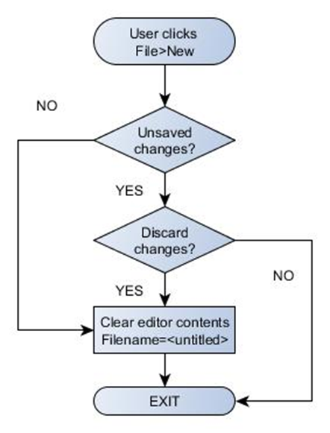
The figure below illustrates the signalling flow for the File>New action. The user has the QML edit Page open and then selects New from the the File menu. This emits the signal file New Requested which has been connected to the slot with the same name in the C++ side. We will pass the edit Page. content property (= the current content as a string) to the file New Requested slot and compare that to the current content. If they match we will call new Confirmed slot which will clear the current content and emit the signal editor Cleared. This will invoke the QML event handler on Editor Cleared that will clear the editor buffer and initialize the file name and path (and return control to the user).

- Opening an existing File:
The Text Editor user can open an existing file by opening the file menu and selecting “Open”. If there are unsaved changes we need to ask whether we can discard the changes. The file browser can then be used to select a file. These steps are shown in the flowchart below.
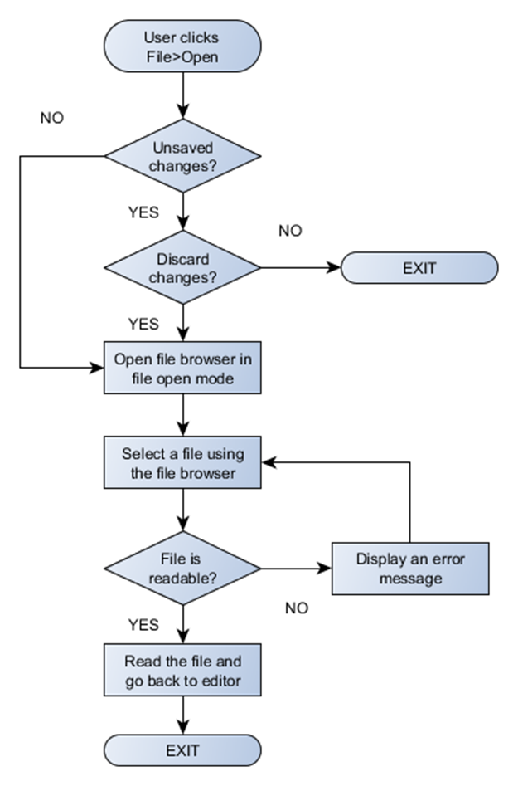

The signalling flow is shown below. As before we will check if there are unsaved changes. If there are no unsaved changes or if the user decides to discard the changes we will emit the signal browse Requested which will trigger the on Browse Requested event handler on the QML side. This will open the browse Page (will be pushed into the page stack). As input the browse Page needs to know the path to browse and whether we are browsing to open or save a file.

WORKFLOW/PROGRAM FLOW:
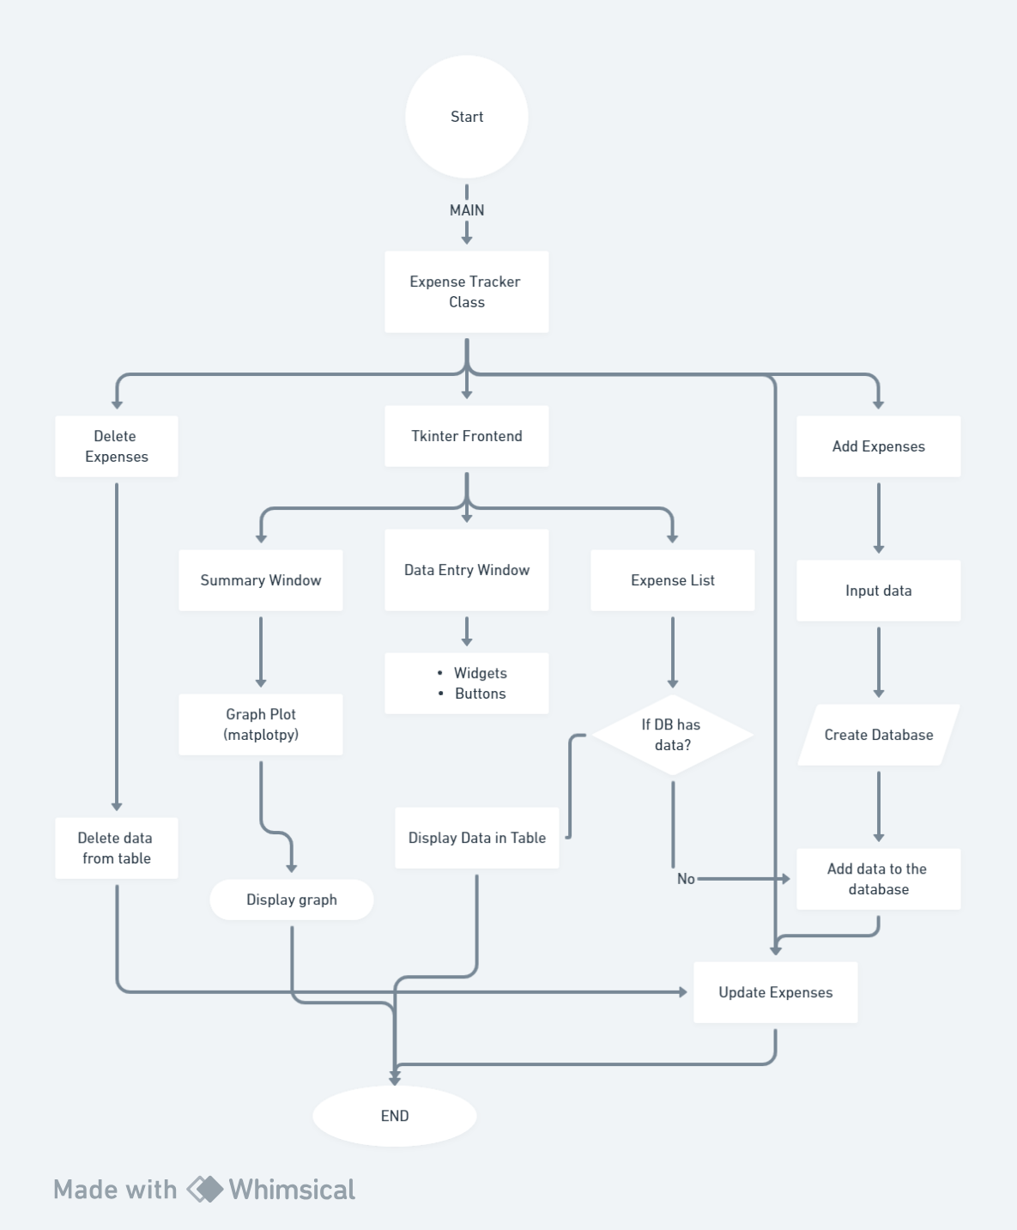
LITERATURE REVIEW:
Daily Expense Tracker System is designed to keep a track of Income-Expense of an organisation on a day-to-day basis. This System divides the Income based on daily expenses. If exceed day’s expense, system will calculate income and will provide new daily expense allowed amount. Daily expense tracking System will generate report at the end of month to show Income-Expense graph. And employees send reports to the manager for verification. Manager send final reports to administrator .Based on the final reports system predict the next month expense . It will helps to manage over all expense and income . Businesses utilize expense management software to process, pay, and audit employee-initiated expenses. The software includes capabilities for employees to input expenses for approval through a forms. Expense management software simplifies and automates a business’ expense entry, eliminates paper trail, and reduces administrative effort. Expense management software allows administrators to have full visibility of and track employee use of business financial resources. Expense management software analyzes overall expenses, identifies cost-saving opportunities, and controls excessive spending.“Expense Tracker” is developed to manage the daily expenses in a more efficient and manageable way. By using this application. we can reduce the manual calculations of the daily expenses and keep track of the expenditure. In this application, user can provide his income to calculate his total expenses per day and these results will be stored for each user. The application has the provision to predict the income and expense for the manager using data mining. Budgeting systematically and Expense Tracking takes a crucial role in managing the expenses of business organizations. Expense tracking (for managing the employee developed expenses) will bring in several advantages for an organization. That are helpful for the stake-holders in processes of expense. The expense tracker will help any organization to deal with all their expenses more efficiently. By using software for managing expense tracking will help to control unnecessary expenses. There are several benefits and advantages of using online expense trackers, expense tracking makes any organization run faster and smoother.
II. EXISTING SYSTEM
A) How it Actually Works In existing, we need to maintain the Excel sheets, CSV etc. files for the user daily and monthly expenses. In existing, there is no as such complete solution to keep a track of its daily expenditure easily. To do so a personas to keep a log in a diary or in a computer, also all the calculations needs to be done by the user which may sometimes results in errors leading to losses.
B) Drawbacks of the Existing System
There can be many disadvantages of using a manual accounting system. Accounting, for any business, can be a complex undertaking. A manual accounting system requires you to understand the accounting process in a way that may be unnecessary with a computerized accounting system. This can be an advantage or a disadvantage, depending on the person doing the bookkeeping; often, a specially trained professional is needed to ensure that accounting is done properly. Unraveling the complexity of your financial records by hand may be time consuming. Since it takes time to generate reports.
III. PROPOSED SYSTEM
To reduce manual calculations, we propose an application. This application allows users to maintain a digital automated diary. Each user will be required to register on the system at registration time, the user will be provided id, which will be used to maintain the record of each unique user. Expense Tracker application which will keep a track of Income-Expense of a user on a day to day basis. The best organizations have a way of tracking and handling these reimbursements. This ideal practice guarantees that the expenses tracked are accurately and in a timely manner. From a company perspective, timely settlements of these expenses when tracked well will certainly boost employees' morale. Additional feature of Expense and income prediction helps to better budjet management
A) Advantages
The best organizations have a way of tracking and handling these reimbursements. This ideal practice guarantees that the expenses tracked are accurately and in a timely manner. From a company perspective, timely settlements of these expenses when tracked well will certainly boost employees' morale Financially Aware and Improve Money Management tracking your expenditures ensures you achieve your project financial targets. How is that? By clearly understanding your project spending using project budget limits, you can aptly make the necessary changes to complete your project within time and budget. Effective expense tracking and reporting to avoid conflict. As a project manager or business owner, you can set clear policies for the expense types and reimbursement limits to avoid misunderstandings are about costs. Tracking the project expenses by asking team members to provide receipts is helpful to avoid conflict and maintain compliance also. An excellent reporting mechanism is extremely helpful to support the amount to be reimbursed to your team and also invoicing to your customer.
Helps anticipate the costs of similar projects When you formally track and report expenses, you have a permanent documentation which helps you correctly anticipate expenses for similar projects in the future. This is even more significant when it comes to budget-making process. Tracking the amount of money spent on the projects is important to invoice customers and determine the cost & profitability analysis when your company is providing services to another company. On the other hand, expense tracking or internal project is important for cost and ROI calculation. Understanding how this money is being utilized across the project is such a significant issue. The consequence for not properly tracking and reporting project expenses may lead to a budgetary issues.
The new system has overcome most of the limitations of the existing system and works according to the design specification given. The project what we have developed is work more efficient than the other income and expense tracker. The project successfully avoids the manual calculation for avoiding calculating the income and expense per month. The modules are developed with efficient and also in an attractive manner. The developed systems dispense the problem and meet the needs of by providing reliable and comprehensive information. All the requirements projected by the user have been met by the system. The newly developed system consumes less processing time and all the details are updated and processed immediately. Since the screen provides online help messages and is very userfriendly, any user will get familiarized with its usage. Module s are designed to be highly flexible so that any failure requirements can be easily added to the modules without facing many problems. The best organizations have a way of tracking and handling these reimbursements. This ideal practice guarantees that the expenses tracked are accurately and in a timely manner. From a company perspective, timely settlements of these expenses when tracked well will certainly boost your employees' morale Quickly Determine How Profitable Business Is Effective expense tracking and reporting to avoid conflict.

TECHNOLOGIES USED:
Python is a high-level, general-purpose programming language. Its design philosophy emphasizes code readability with the use of significant indentation.^{[31]}
Python is dynamically typed and garbage-collected. It supports multiple programming paradigms, including structured (particularly procedural), object-oriented and functional programming. It is often described as a "batteries included" language due to its comprehensive standard library.^{[32][33]}
Guido van Rossum began working on Python in the late 1980s as a successor to the ABC programming language and first released it in 1991 as Python 0.9.0.^{[34]} Python 2.0 was released in 2000. Python 3.0, released in 2008, was a major revision not completely backward-compatible with earlier versions. Python 2.7.18, released in 2020, was the last release of Python 2
Python is a multi-paradigm programming language. Object-oriented programming and structured programming are fully supported, and many of their features support functional programming and aspect-oriented programming (including metaprogramming^{[64]} and metaobjects).^{[65]} Many other paradigms are supported via extensions, including design by contract^{[66][67]} and logic programming.^{[68]}
Python uses dynamic typing and a combination of reference counting and a cycle-detecting garbage collector for memory management.^{[69]} It uses dynamic name resolution (late binding), which binds method and variable names during program execution.
Its design offers some support for functional programming in the Lisp tradition. It has filter, map and reduce functions; list comprehensions, dictionaries, sets, and generator expressions.^{[70]} The standard library has two modules (itertools and functools) that implement functional tools borrowed from Haskell and Standard ML.^{[71]}
Its core philosophy is summarized in the document The Zen of Python (PEP 20), which includes aphorisms such as:^{[72]}
- Beautiful is better than ugly.
- Explicit is better than implicit.
- Simple is better than complex.
- Complex is better than complicated.
- Readability counts.
Rather than building all of its functionality into its core, Python was designed to be highly extensible via modules. This compact modularity has made it particularly popular as a means of adding programmable interfaces to existing applications. Van Rossum's vision of a small core language with a large standard library and easily extensible interpreter stemmed from his frustrations with ABC, which espoused the opposite approach.^{[40]}
Python strives for a simpler, less-cluttered syntax and grammar while giving developers a choice in their coding methodology. In contrast to Perl's "there is more than one way to do it" motto, Python embraces a "there should be one—and preferably only one—obvious way to do it" philosophy.^{[72]} Alex Martelli, a Fellow at the Python Software Foundation and Python book author, wrote: "To describe something as 'clever' is not considered a compliment in the Python culture."^{[73]}
Python's developers strive to avoid premature optimization and reject patches to non-critical parts of the CPython reference implementation that would offer marginal increases in speed at the cost of clarity.^{[74]} Execution speed can be improved by moving speed-critical functions to extension modules written in languages such as C, or by using a just-in-time compiler like PyPy. It is also possible to cross-compile to other languages, but it either doesn't provide the full speed-up that might be expected, since Python is a very dynamic language, or a restricted subset of Python is compiled, and possibly semantics are slightly changed.^{[75]} Python's developers aim for it to be fun to use. This is reflected in its name—a tribute to the British comedy group Monty Python^{[76]}—and in occasionally playful approaches to tutorials and reference materials, such as the use of the terms "spam" and "eggs" (a reference to a Monty Python sketch) in examples, instead of the often-used "foo" and "bar".^{[77][78]}
A common neologism in the Python community is pythonic, which has a wide range of meanings related to program style. "Pythonic" code may use Python idioms well, be natural or show fluency in the language, or conform with Python's minimalist philosophy and emphasis on readability. Code that is difficult to understand or reads like a rough transcription from another programming language is called unpythonic.^{[79][80]}
Python was conceived in the late 1980s^{[40]} by Guido van Rossum at Centrum Wiskunde & Informatica (CWI) in the Netherlands as a successor to the ABC programming language, which was inspired by SETL,^{[41]} capable of exception handling and interfacing with the Amoeba operating system.^{[10]} Its implementation began in December 1989.^{[42]} Van Rossum shouldered sole responsibility for the project, as the lead developer, until 12 July 2018, when he announced his "permanent vacation" from his responsibilities as Python's "benevolent dictator for life", a title the Python community bestowed upon him to reflect his long-term commitment as the project's chief decision-maker.^{[43]} In January 2019, active Python core developers elected a five-member Steering Council to lead the project.^{[44][45]}
Python 2.0 was released on 16 October 2000, with many major new features such as list comprehensions, cycle-detecting garbage collection, reference counting, and Unicode support.^{[46]} Python 3.0, released on 3 December 2008, with many of its major features backported to Python 2.6.x^{[47]} and 2.7.x. Releases of Python 3 include the 2to3 utility, which automates the translation of Python 2 code to Python 3.^{[48]}
Python 2.7's end-of-life was initially set for 2015, then postponed to 2020 out of concern that a large body of existing code could not easily be forward-ported to Python 3.^{[49][50]} No further security patches or other improvements will be released for it.^{[51][52]} Currently only 3.8 and later are supported (2023 security issues were fixed in e.g. 3.7.17, the final 3.7.x release^{[53]}).
LIBRARIES:

TKINTER:

The Python text editor using Tkinter, several modules are used to implement the graphical user interface (GUI) and specific functionalities. Here's a summary of the modules used:
1. tkinter Module:
Used for creating the main GUI components, such as windows, text widgets, menus, and labels.
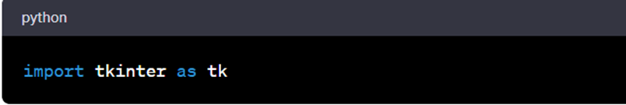
2. tkinter.ttk Module:
Used for accessing themed Tkinter widgets, which includes additional styling options.
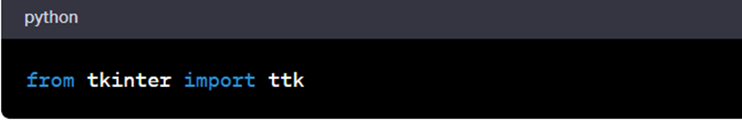
3. tkinter.filedialog Module:
Used for creating file dialogs to handle opening and saving files.
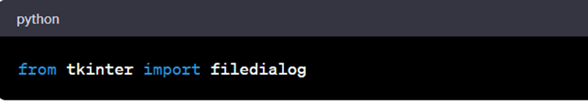
4. tkinter.simpledialog Module:
Used for creating simple dialogs to get user input, particularly for search and replace queries.
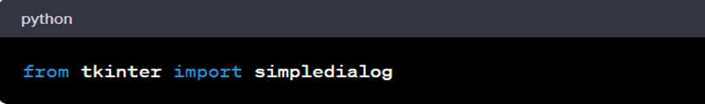

5. tkinter.font Module:
Used for handling fonts and font sizes in the text widget.
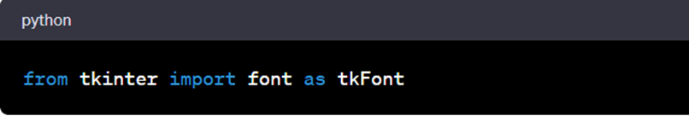
Here, five modules from the standard Python library are used in this project to create the GUI and implement various functionalities. These modules provide the necessary tools and components for building a simple text editor with basic editing features.

MATPLOTLIB:

matplotlib.pyplot is a collection of functions that make matplotlib work like MATLAB. Each pyplot function makes some change to a figure: e.g., creates a figure, creates a plotting area in a figure, plots some lines in a plotting area, decorates the plot with labels, etc.
In matplotlib.pyplot various states are preserved across function calls, so that it keeps track of things like the current figure and plotting area, and the plotting functions are directed to the current axes (please note that "axes" here and in most places in the documentation refers to the axes part of a figure and not the strict mathematical term for more than one axis).
The implicit pyplot API is generally less verbose but also not as flexible as the explicit API. Most of the function calls you see here can also be called as methods from an Axes object. We recommend browsing the tutorials and examples to see how this works. See Matplotlib Application Interfaces (APIs) for an explanation of the trade-off of the supported user APIs.
Matplotlib is an amazing visualization library in Python for 2D plots of arrays. Matplotlib is a multi-platform data visualization library built on NumPy arrays and designed to work with the broader SciPy stack. It was introduced by John Hunter in the year 2002. One of the greatest benefits of visualization is that it allows us visual access to huge amounts of data in easily digestible visuals. Matplotlib consists of several plots like line, bar, scatter, histogram, etc.
Installation: Windows, Linux, and macOS distributions have Matplotlib and most of its dependencies as wheel packages. Run the following command to install the Matplotlib package. But before that make sure Python and PIP are already installed on a system:

Types of Matplotlib:
Matplotlib comes with a wide variety of plots. Plots help to understand trends, and patterns, and to make correlations. They’re typically instruments for reasoning about quantitative information. Some of the sample plots are covered here.
- Matplotlib Line Plot
- Matplotlib Bar Plot
- Matplotlib Histograms Plot
- Matplotlib Scatter Plot
- Matplotlib Pie Charts
- Matplotlib Area Plot

Matplotlib Line Plot:
By importing the matplotlib module, defines x and y values for a plotPython, plots the data using the plot() function and it helps to display the plot by using the show() function . The plot() creates a line plot by connecting the points defined by x and y values.

SQLITE3:
SQLite is a C library that provides a lightweight disk-based database that doesn’t require a separate server process and allows accessing the database using a nonstandard variant of the SQL query language. Some applications can use SQLite for internal data storage. It’s also possible to prototype an application using SQLite and then port the code to a larger database such as PostgreSQL or Oracle.
The sqlite3 module was written by Gerhard Häring. It provides an SQL interface compliant with the DB-API 2.0 specification described by PEP 249, and requires SQLite 3.7.15 or newer.
This document includes four main sections:
- Tutorial teaches how to use the sqlite3 module.
- Reference describes the classes and functions this module defines.
- How-to guides details how to handle specific tasks.
- Explanation provides in-depth background on transaction control.
In this tutorial, you will create a database of Monty Python movies using basic sqlite3 functionality. It assumes a fundamental understanding of database concepts, including cursors and transactions.
First, we need to create a new database and open a database connection to allow sqlite3 to work with it. Call sqlite3.connect() to create a connection to the database tutorial.db in the current working directory, implicitly creating it if it does not exist:

import sqlite3
con = sqlite3.connect("tutorial.db")

The returned Connection object con represents the connection to the on-disk database.
In order to execute SQL statements and fetch results from SQL queries, we will need to use a database cursor. Call con.cursor() to create the Cursor:

cur = con.cursor()

Now that we’ve got a database connection and a cursor, we can create a database table movie with columns for title, release year, and review score. For simplicity, we can just use column names in the table declaration – thanks to the flexible typing feature of SQLite, specifying the data types is optional. Execute the CREATE TABLE statement by calling cur.execute(...):
cur.execute("CREATE TABLE movie(title, year, score)")

We can verify that the new table has been created by querying the sqlite_master table built-in to SQLite, which should now contain an entry for the movie table definition (see The Schema Table for details). Execute that query by calling cur.execute(...), assign the result to res, and call res.fetchone() to fetch the resulting row:
>>>
>>> res = cur.execute("SELECT name FROM sqlite_master")
>>> res.fetchone()
('movie',)

We can see that the table has been created, as the query returns a tuple containing the table’s name. If we query sqlite_master for a non-existent table spam, res.fetchone() will return None:
>>>
>>> res = cur.execute("SELECT name FROM sqlite_master WHERE name='spam'")
>>> res.fetchone() is None
True

Now, add two rows of data supplied as SQL literals by executing an INSERT statement, once again by calling cur.execute(...):
cur.execute("""
INSERT INTO movie VALUES
('Monty Python and the Holy Grail', 1975, 8.2),
('And Now for Something Completely Different', 1971, 7.5)
""")

The INSERT statement implicitly opens a transaction, which needs to be committed before changes are saved in the database (see Transaction control for details). Call con.commit() on the connection object to commit the transaction:
con.commit()
The result is a list of two tuples, one per row, each containing that row’s score value.
Now, insert three more rows by calling cur.executemany(...):
data = [
("Monty Python Live at the Hollywood Bowl", 1982, 7.9),
("Monty Python's The Meaning of Life", 1983, 7.5),
("Monty Python's Life of Brian", 1979, 8.0),
]
cur.executemany("INSERT INTO movie VALUES(?, ?, ?)", data)
con.commit() # Remember to commit the transaction after executing INSERT.

Notice that ? placeholders are used to bind data to the query. Always use placeholders instead of string formatting to bind Python values to SQL statements, to avoid SQL injection attacks (see How to use placeholders to bind values in SQL queries for more details).

FEASIBILITY STUDY :

The feasibility study for the Expense Tracker Project is a critical step in assessing the viability and potential success of the proposed financial management system. This study encompasses various aspects, including technical, operational, economic, and scheduling considerations, to determine whether the project is feasible within the defined constraints and objectives.

Key considerations involved in the feasibility analysis are:

1. Introduction:
The Expense Tracker Project's feasibility study delves into various dimensions to ascertain its viability and potential success. This multifaceted examination includes technical, operational. The comprehensive feasibility study on the Expense Tracker Project indicates a favorable outlook. Technical, operational, economic, and scheduling considerations align with the project's objectives. The study supports the belief that the Expense Tracker Project is a viable and beneficial solution for individuals and businesses seeking effective financial management. With careful planning, adherence to ethical standards, and a commitment to quality, the project is poised to deliver a valuable tool for enhancing financial well-being and responsibility.

2. Technical Feasibility:
The technical feasibility assessment begins by scrutinizing the required technology infrastructure for the project. This encompasses compatibility with existing systems, availability of necessary software and hardware, and the feasibility of implementing advanced features such as automated data entry and real-time reporting. Preliminary analyses reveal that the project is technically feasible, leveraging contemporary web and mobile application development technologies.

3. Operational Feasibility:
Operational feasibility evaluates the practical aspects of integrating the Expense Tracker Project within the intended user base. The focus lies on the platform's ease of use, user training requirements, and potential impact on existing business processes. The project's commitment to a user-friendly interface and financial literacy positively influences operational feasibility. To further support users, comprehensive training modules will be developed, ensuring that individuals and businesses can readily embrace and maximize the benefits of the Expense Tracker.

4. Economic Feasibility:
Economic feasibility examines the financial viability of the project, weighing development costs against potential revenue streams and return on investment. Despite initial development expenditures, the long-term benefits, such as enhanced efficiency in expense management and potential revenue from premium features or strategic partnerships, render the Expense Tracker Project economically feasible. The project's design, catering to both individual users and businesses, creates opportunities for sustainable revenue models.

5. Scheduling Feasibility:
Scheduling feasibility evaluates whether the project can be completed within a reasonable timeframe. A meticulous project plan has been developed, outlining key milestones, resource allocation, and potential risks. Regular monitoring and adaptive adjustments to the schedule will be implemented to ensure the project remains on track and meets its deadlines. This dynamic approach enhances scheduling feasibility, acknowledging the need for flexibility in response to unforeseen challenges.

PROPOSED WORK:
Proposed Work by the Expense Tracker Project: A Comprehensive Overview

1. Project Scope:
The proposed work by the Expense Tracker Project is ambitious in its scope, aiming to revolutionize the landscape of financial management for individuals and businesses. The core objective is to develop a robust and user-friendly expense tracking system that goes beyond the conventional, offering innovative features and addressing the diverse needs of users.

2. User Interface Design:
A key component of the proposed work is the development of an intuitive and aesthetically pleasing user interface. The interface will prioritize ease of use, ensuring that users, regardless of their level of financial literacy, can effortlessly navigate and utilize the platform. Interactive dashboards, customizable widgets, and a responsive design are integral to creating a seamless user experience.

3. Automated Data Entry:
The Expense Tracker Project proposes the implementation of advanced automation technologies to streamline data entry. Integration with banking systems and financial institutions will allow users to automatically import transaction data, minimizing manual input and reducing the likelihood of errors. This feature is designed to enhance efficiency and accuracy in recording financial transactions.

4. Categorization and Classification:
A fundamental aspect of the proposed work involves the development of a sophisticated categorization and classification system. Users will be able to categorize their expenses into fixed, variable, and discretionary categories. Customizable tags and labels will further refine data, providing users with a granular understanding of their spending patterns and facilitating targeted financial analysis.

5. Real-Time Reporting and Analysis:
The project envisions real-time reporting as a cornerstone feature. Users will have access to dynamic and visually appealing reports that break down expenditures over specified periods. Graphs, charts, and predictive analytics will empower users to identify trends, areas of overspending, and potential future expenses, facilitating data-driven decision-making.

6. Educational Resources for Financial Literacy:
In addition to its functional components, the Expense Tracker Project proposes the incorporation of educational resources to enhance financial literacy. The platform will offer tutorials, guides, and informative content to help users understand financial concepts, interpret reports, and make informed financial decisions. This aspect aligns with the project's broader goal of contributing to financial education.

7. Security and Privacy Measures:
The proposed work places a strong emphasis on security and privacy. The development team will implement robust encryption protocols, multi-factor authentication, and other security measures to safeguard users' sensitive financial information. Ensuring the highest standards of privacy and data integrity is a priority to build trust among users.

8. Mobile Accessibility:
Recognizing the prevalence of mobile devices in daily life, the proposed work includes the development of mobile applications. This ensures that users can access the Expense Tracker seamlessly on their smartphones, providing convenience and flexibility in managing their finances on the go.

OUTPUT ANALYSIS :
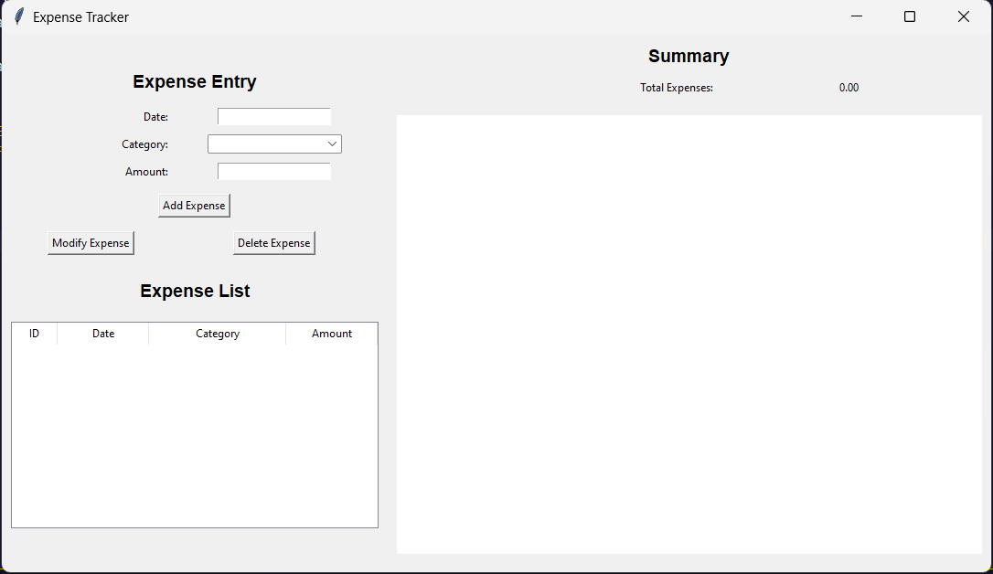
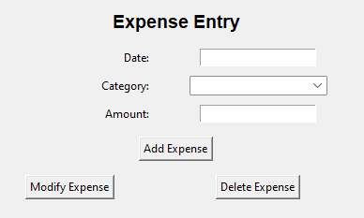

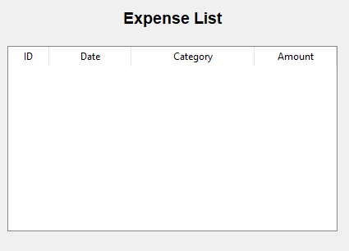
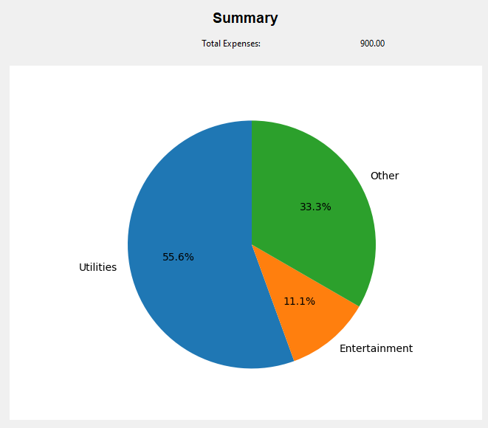

TEST/ RESULT ANALYSIS:

INPUT 01:
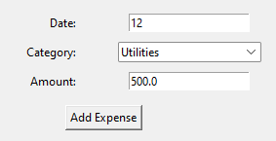

OUTPUT 01:

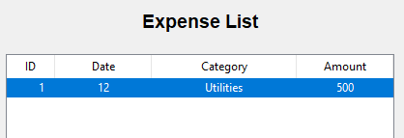

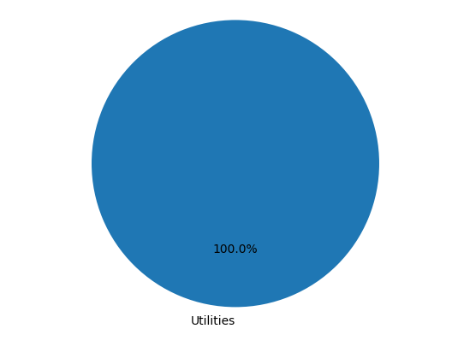

INPUT 02:
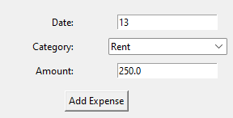

OUTPUT 02:

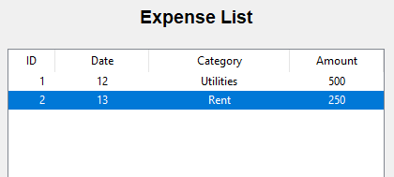

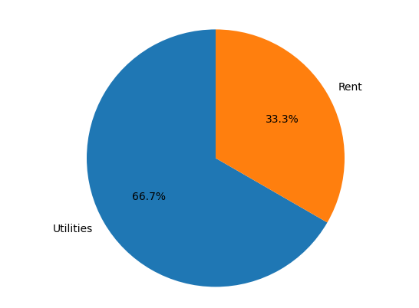

CONCLUSION:
In summary, the Expense Tracker Project stands as a testament to the commitment to transforming the landscape of financial management. The proposed work encompasses a holistic approach, addressing diverse user needs and weaving together innovative features to create a powerful expense tracking system. The user-friendly interface, automated data entry, sophisticated categorization, and real-time reporting collectively contribute to an intuitive and efficient financial management experience.
Crucially, the project goes beyond mere functionality. It aspires to contribute to financial literacy, providing users with educational resources to enhance their understanding of financial concepts. By facilitating informed decision-making and offering insights into spending patterns, the Expense Tracker Project becomes not just a tool but a companion in users' journeys toward financial well-being.
The emphasis on security and privacy underscores the project's commitment to user trust. Through robust encryption protocols and multi-factor authentication, the Expense Tracker Project ensures that users can manage their finances with confidence, knowing that their sensitive information is safeguarded.
Mobile accessibility expands the reach of the project, acknowledging the dynamic lifestyles of users who rely on smartphones for daily tasks. The scalability of the platform ensures that it remains adaptable to evolving user needs and technological advancements, fostering a sustainable and enduring solution.
As the Expense Tracker Project concludes its development phase, there is a sense of excitement about the positive impact it can have on individuals and businesses alike. It is not merely a project; it is a catalyst for change, empowering users to navigate their financial journeys with confidence, make informed decisions, and ultimately achieve greater financial well-being. The Expense Tracker Project is not just about tracking expenses; it's about empowering lives through financial empowerment.

REFERENCES:
WEBSITES:-
- http://wikipedia.org
- https://brainly.in
- https://www.geeksforgeeks.org
- https://www.programiz.com
- https://github.com
BOOKS:-
- Python , The basics
- PY Libraries Core, Guaven wan

GUI with python using Tkinter, Abert roger

RESEARCH PAPERS:-

- Expense Tracker Prof Miriam Thomas1 , Lekshmi P2 , and Dr. Mahalekshmi T3 Volume 9, Issue 4, September 2020
- Expense Tracker ATIYA KAZI1 , PRAPHULLA S. KHERADE2 , RAJ S. VILANKAR3 , PARAG M. SAWANT4 1 Professor, Department of Information Technology, Finolex Academy of Management and Technology, Ratnagiri, Maharashtra, India. 2, 3, 4 Department of Information Technology, Finolex Academy of Management and Technology, Ratnagiri, Maharashtra, India.

